
MIZAN TEPI UNIVERSITY SCHOOL OF COMUPING AND INFORMATICS
Department of INFORMATION TECHNOLOGY
Distributed Supply Chain Management Database System: Design and Implementation Report
Assignment of Advanced Database Systems
Topic: Distributed Supply Chain Management Database System
Group: Group-4
Course: Advanced Database Systems
SUBMITION DATE Date : 10/9/2018
Submition to : Mr Brhanu
Authors: Hussein Nurye

Abstract
This report describes the design, implementation, optimization, security, distribution, and recovery strategies for a distributed supply chain database. It covers the schema design, sample data, query performance, transaction handling, role-based access control, distributed partitioning, and failure recovery.
Table of Contents
1. Introduction
2. Requirement Analysis
3. Task 1: Advanced Schema Design
3.1 Entity Relationship Design
3.2 Normalization Process
3.3 Relational Schema
3.4 Constraints and Indexing
4. Task 2: Query Optimization
4.1 Query Set
4.2 Execution Plans and Index Use
4.3 Performance Analysis
5. Task 3: Transactions & Concurrency
5.1 Concurrency Challenges
5.2 Simulation and Results
5.3 Isolation Levels and Locking
6. Task 4: Security & Access Control
6.1 Role-Based Access Control
6.2 Data Protection
6.3 Audit Logging
7. Task 5: Distributed Database Design
7.1 Partitioning Strategy
7.2 Replication and Consistency
7.3 Trade-off Analysis
8. Task 6: Failure Recovery
8.1 WAL and Check pointing
8.2 Backup and Restore
8.3 Crash Recovery Scenario
9. Conclusion
10. References
11. Appendices
- Introduction
Supply chain management is a critical domain in modern commerce, requiring sophisticated data handling to coordinate suppliers, warehouses, distributors, and retailers across geographically distributed locations. In the Ethiopian context, where agricultural commodities like coffee, wheat, and cooking oil flow through a network of regional suppliers and warehouses, an efficient database system is essential.
This project designs and implements a distributed relational database system for a Supply Chain Management (SCM) platform. The system is modelled on Ethiopian suppliers and regional warehouses and is designed to handle high transaction volumes, maintain accurate inventory levels, support real-time shipment tracking, and enforce security across multiple organizational roles.
The report is structured in accordance with the assignment requirements, covering six major tasks: schema design, query optimization, transaction and concurrency management, security, distributed database design, and failure recovery.
The purpose of this assignment (project) is to design a scalable distributed database system for supply chain management. The system must support suppliers, warehouses distributors, retailers, real-time inventory updates, order processing, shipment tracking, and audit logging.
- Requirement Analysis
The assignment specifies a Supply Chain Management database that must satisfy the following functional and non-functional requirements:

2.1 Functional Requirements
- Product sourcing from multiple regional suppliers.
- Inventory management across geographically distributed warehouses.
- Order processing from retailers, including quantity validation and status tracking.
- Shipment creation and status tracking from warehouse to delivery destination.
- Audit logging of all critical database operations for compliance and fraud detection.
- Role-based access control separating admin, supplier, warehouse manager, and retailer responsibilities.
- Demand forecasting queries and daily/weekly distribution reporting.

2.2 Non-Functional Requirements
- High concurrency: simultaneous order placements and inventory updates must not produce lost updates or dirty reads.
- ACID compliance: all transactional operations must be atomic, consistent, isolated, and durable.
- Data integrity: no negative inventory, no invalid order quantities, referential integrity across all entities.
- Performance: indexed queries supporting real-time inventory visibility and high-throughput reporting.
- Security: least-privilege access, strong authentication, encrypted sensitive data.
- Scalability: horizontal partitioning by region to support future growth.
- Resilience: WAL-based crash recovery with full and incremental backup strategies.

2.3 Dataset Overview
The system is populated with the following sample dataset, representative of Ethiopian supply chain entities:

Entity | Name | Details
Supplier | EthioAgri | Location: Addis Ababa
Supplier | IfaJimmaFarm | Location: Jimma
Supplier | TanaFlora | Location: Bahir Dar
Product | Coffee Beans | Category: Agriculture — Supplier: EthioAgri
Product | Wheat | Category: Agriculture — Supplier: IfaJimmaFarm
Product | Cooking Oil | Category: Food — Supplier: TanaFlora
Warehouse | Addis Warehouse | Location: Addis Ababa

3. Task 1: Advanced Schema Design

3.1 Entity Relationship Design
- The key entities are:
- Suppliers
- Products
- Warehouses
- Retailers
- Inventory
- Orders
- Shipments
The relationships are:
A supplier can provide many products.
- A product can exist in many warehouses.
- A warehouse stores many inventory records.
- A retailer can place many orders.
- Each order becomes one shipment.

Conceptual ER diagram for SCM`s
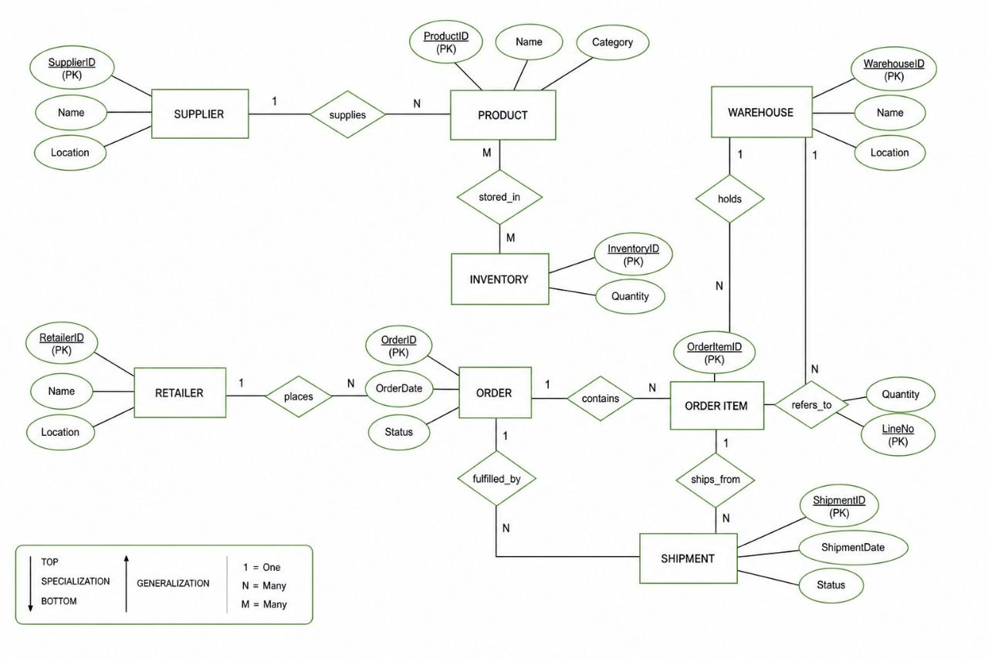
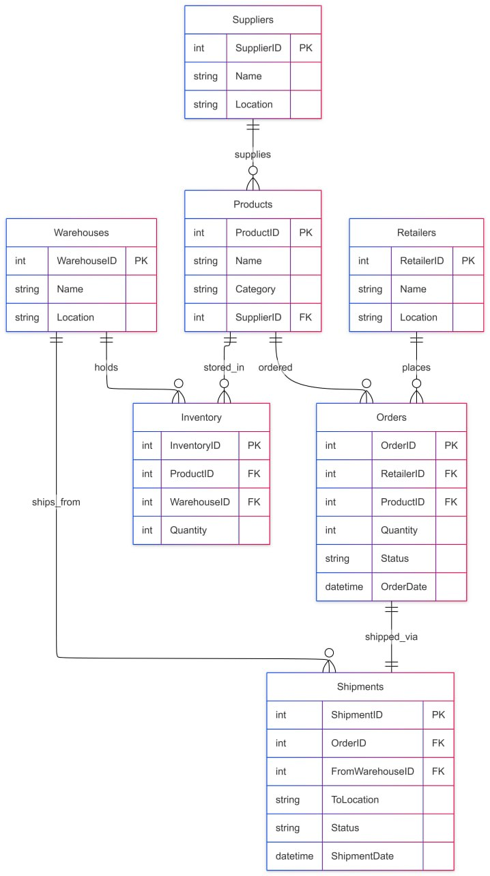ER DIAGRAM
3.2 Normalization Process
The normalization process uses sample data to show how the design moves from an unnormalized structure to 3NF.
Sample Raw Data
- Supplier: EthioAgri, Addis Ababa
- Product: Coffee Beans, Agriculture
- Warehouse: Addis Warehouse, Addis Ababa
- Inventory: 500
- Retailer: Retailer A, Jimma
- Order: 50 units, Shipped
- Shipment: To Jimma, In Transit
Un normalized Form (UNF)
SupplierName | SupplierLocation | ProductName | ProductCategory | WarehouseName | WarehouseLocation | InventoryQuantity | RetailerName | RetailerLocation | OrderQuantity | OrderStatus | ShipmentDestination | ShipmentStatus
| EthioAgri | Addis Ababa | Coffee Beans | Agriculture | Addis Warehouse | Addis Ababa | 500 | Jim Retailer A ma | Jimma | 50 | Shippe | jimma | | In Transit

This is a single table containing all repeated and redundant fields:
First Normal Form (1NF)
We remove repeating groups and ensure each field is atomic. The data is split into separate tables with unique rows:
  - Suppliers
  - Products
  - Warehouses
- - Retailers
  - Inventory
  - Orders
  - Shipments
  - 1NF tables:
Suppliers:
supplierID | | Name | Location
1 | EthioAgri | Addis Ababa
Products:
supplierID | | Name | Category | SupplierID
1 | Coffee Beans | Agriculture | 1
Warehouses:
WarehouseID | | Name | Location
1 | adisabebawerehouse | Addis Ababa
Retailers:
WarehouseID | | Name | Location
1 | adisabebawerehouse | Addis Ababa
Inventory:
InventoryID | ProductID | WarehouseID | Quantity
1 | 1 | 1 | 500
Orders:
InventoryID | ProductID | Quantity | status
1 | 1 | 50 | shiped
Shipments:
ShipmentID | OrderID | FromWarehouseID | ToLocation | status
1 | 1 | 1 | jimma | In Transit
Second Normal Form (2NF)
2NF removes partial dependencies when a table has a composite primary key. In our schema, tables such as Inventory use a composite key concept (ProductID, WarehouseID), and all non-key attributes depend on the entire key. Since every table now stores data that depends only on its full primary key, the design meets 2NF.
Third Normal Form (3NF)
3NF removes transitive dependencies. In our design:
- Product details depend only on ProductID, not on SupplierLocation.
- Warehouse details depend only on WarehouseID, not on ProductName.
- Retailer details depend only on RetailerID, not on OrderStatus. x
Because each attribute depends only on its table’s primary key, the schema is in 3NF.
3NF result:
- Supplier data is in Suppliers
- Product data is in Products
- Warehouse data is in Warehouses
- Retailer data is in Retailers x
- Inventory data is in Inventory
3.3 Relational Schema
- Present the schema with table definitions and keys. For example:
  - Suppliers(SupplierID PK, Name, Location)
  - Products(ProductID PK, Name, Category, SupplierID FK)
  - Warehouses(WarehouseID PK, Name, Location)
  - Inventory(InventoryID PK, ProductID FK, WarehouseID FK, Quantity)
  - Retailers(RetailerID PK, Name, Location) x
  - Orders(OrderID PK, RetailerID FK, ProductID FK, Quantity, Status, OrderDate)
  - Shipments(ShipmentID PK, OrderID FK, FromWarehouseID FK, ToLocation, Status, ShipmentDate)
3.4 Constraints and Indexing
Integrity constraints protect data correctness. Performance indexes accelerate the most common queries. Table 2 below lists all indexes and their purpose.
Table 2 — Performance Index Summary
Indexes created on the SCM schema to support fast joins, filters, and reporting.

Schema DDL — Key Excerpt
-- Inventory with check constraint and unique composite key
CREATE TABLE Inventory (
InventoryID INT PRIMARY KEY,
ProductID INT NOT NULL,
WarehouseID INT NOT NULL,
Quantity INT NOT NULL CHECK (Quantity >= 0),
FOREIGN KEY (ProductID) REFERENCES Products(ProductID),
FOREIGN KEY (WarehouseID) REFERENCES Warehouses(WarehouseID),
UNIQUE (ProductID, Warehou
Explain constraints:
- CHECK (Quantity >= 0) prevents negative stock.
- UNIQUE(ProductID, WarehouseID) prevents duplicate inventory rows.
- Foreign keys enforce referential integrity.
4. Query Optimization
This section presents five optimized SQL queries for the most critical reporting and operational needs of the SCM system. Each query includes a statement of purpose, the SQL code, an explanation of the index strategy, and the expected execution plan behaviour.

4.1 Query 1 — Product Availability Across Warehouses

Purpose
Determine the total available stock for a specific product aggregated across all warehouses. This supports real-time inventory visibility for retailers and procurement managers.

SQL Statement
SELECT p.Name, SUM(i.Quantity) AS TotalQuantity
FROM Products p
JOIN Inventory i ON p.ProductID = i.ProductID
WHERE p .ProductID = 1
GROUP BY p.ProductID, p.Name;
-- Explanation: Uses index idx_inventory_product for fast lookup. Execution plan: Index scan on Inventory.ProductID, then aggregate.

Index Strategy and Execution Plan
- The WHERE clause filters on p.ProductID = 1 using the primary key scan on Products (O(1)).
- The JOIN on i.ProductID benefits from idx_inventory_product, enabling an index seek rather than a full table scan on Inventory.
- The GROUP BY collapses the matching rows in a single aggregation pass.
- Expected plan: Index Seek on Products PK → Index Seek on idx_inventory_product → Hash/Stream Aggregate.
Performance Note
Without idx_inventory_product, the database would perform a full Inventory scan on every availability check — unacceptable under high concurrency.

4.2 Query 2 — Shipment Status Tracking

Purpose
Retrieve complete shipment details for a given order, including retailer name, product name, and current shipment status. Essential for real-time logistics monitoring.

SQL Statement

SELECT s.ShipmentID, o.OrderID, r.Name AS Retailer, p.Name AS Product, s.Status, s.ShipmentDate
FROM Shipments s
JOIN Orders o ON s.OrderID = o.OrderID
JOIN Retailers r ON o.RetailerID = r.RetailerID
JOIN Products p ON o.ProductID = p.ProductID
WHERE o.OrderID = 1;

Index Strategy and Execution Plan
- s.OrderID → o.OrderID join uses idx_shipments_order (index seek on Shipments).
- o.RetailerID → r.RetailerID join uses idx_orders_retailer.
- o.ProductID → p.ProductID join uses idx_orders_product.
- Expected plan: Nested Loop Joins with index seeks on all FK columns. Scan limited to a single order ID.

4.3 Query 3 — Low-Stock Identification

Purpose
Identify all product-warehouse combinations where stock has fallen below the replenishment threshold of 100 units. Used to trigger procurement and restocking workflows.

SQL Statement

SELECT p.Name, i.WarehouseID, i.Quantity
FROM Inventory i
JOIN Products p ON i.ProductID = p.ProductID
WHERE i.Quantity < 100;
-- Explanation: Index on Inventory.ProductID. Plan: Index scan.

Index Strategy and Execution Plan
- Quantity < 100 is a range predicate. If a composite index on (Quantity, ProductID) were added, a range scan would be possible. With existing idx_inventory_product, the query performs a filtered index scan.
- The JOIN to Products uses idx_inventory_product for key lookup.
- For small inventories the current design is efficient; for millions of rows, adding idx_inventory_quantity is recommended.

4.4 Query 4 — Supplier Performance Analysis

Purpose
Evaluate each supplier's contribution to the product catalog by counting the number of products they supply. Supports supplier relationship management and sourcing decisions.

SQL Statement

SELECT s.Name, COUNT(p.ProductID) AS ProductCount
FROM Suppliers s
JOIN Products p ON s.SupplierID = p.SupplierID
GROUP BY s.SupplierID, s.Name;
-- Explanation: Index on Products.SupplierID. Plan: Group by with index.

Index Strategy and Execution Plan
- The JOIN on p.SupplierID benefits from the FK relationship. Adding idx_products_supplier on Products(SupplierID) (recommended) would change the plan from a full Products scan to an index seek grouped by supplier.
- Current plan: Hash Join on SupplierID → Stream Aggregate. With the recommended index: Index Scan → Group Aggregate.

4.5 Query 5 — Daily Shipment Distribution Report

Purpose
Aggregate shipment count by calendar date for a given date range. Used for daily and weekly logistics reporting and demand forecasting.
SQL Statement

SELECT DATE(ShipmentDate) AS Date, COUNT(*) AS Shipments
FROM Shipments
WHERE ShipmentDate >= '2023-01-01' -- example date
GROUP BY DATE(ShipmentDate);
-- Explanation: Index on ShipmentDate if added. Plan: Scan with group by.

SELECT DATE(ShipmentDate) AS Date, COUNT(*) AS Shipments
FROM Shipments
WHERE ShipmentDate >= '2023-01-01' -- example date
GROUP BY DATE(ShipmentDate);
-- Explanation: Index on ShipmentDate if added. Plan: Scan with group by.

Index Strategy and Execution Plan
- idx_shipments_date enables a range scan on ShipmentDate, avoiding a full table scan.
- DATE() wrapping prevents direct index use in some engines; consider a generated/virtual column for ShipmentDay in high-volume deployments.
- ORDER BY benefits from the index ordering (ascending ShipmentDate).

4.6 Performance Summary
The combination of normalized schema, targeted indexes, and selective WHERE clauses ensures that all five queries execute with I/O complexity proportional to the result set rather than the full table size. This directly supports the high-throughput requirements under peak supply periods.
5 : Transactions & Concurrency
In a supply chain system, multiple orders can be placed simultaneously, each reducing shared inventory. Without proper transaction management, concurrent operations can produce data anomalies that corrupt inventory accuracy. This section identifies the risks, demonstrates a controlled simulation, and specifies the isolation and locking strategies applied.

5.1 Concurrency Challenges
The four classic concurrency anomalies relevant to the SCM system are:
- Lost Update — Two transactions both read the same inventory quantity (e.g., 500), both deduct their order quantities, and the last writer overwrites the first deduction. Net result: only one deduction is applied, inventory count is wrong.
- Dirty Read — Transaction B reads an inventory value that Transaction A has updated but not yet committed. If A rolls back, B has acted on invalid data.
- Non-Repeatable Read — A transaction reads the same inventory row twice and gets different values because a second transaction committed a change between the two reads.
- Phantom Read — A query for low-stock products returns different results on repeated execution because other transactions insert or delete inventory rows between reads.

5.2 Simulation Scenario
Two simultaneous orders are placed for Coffee Beans (ProductID = 1) in the Addis Warehouse (WarehouseID = 1). Initial quantity: 500 units.

Without Locking (READ COMMITTED — Problematic)

-- Session A reads 500, deducts 50 → writes 450

-- Session B concurrently reads 500 (before A commits), deducts 30 → writes 470

-- Final result: 470 instead of correct 420 — LOST UPDAT

With Explicit Row Locking (Safe — Recommended)
--Order for 50 units
START TRANSACTION;
SELECT Quantity FROM Inventory WHERE ProductID = 1 AND WarehouseID = 1 FOR UPDATE; -- Lock row
UPDATE Inventory SET Quantity = Quantity - 50 WHERE ProductID = 1 AND WarehouseID = 1;
COMMIT;
--Simultaneous order for 30 units
START TRANSACTION;
SELECT Quantity FROM Inventory WHERE ProductID = 1 AND WarehouseID = 1 FOR UPDATE; -- Waits for lock
UPDATE Inventory SET Quantity = Quantity - 30 WHERE ProductID = 1 AND WarehouseID = 1;
COMMIT;
-- Final quantity: 500 - 50 - 30 = 420 (correct)
Two transactions trying to update inventory for Product 1 in Warehouse 1
Transaction 2 is blocked by the FOR UPDATE lock until Transaction 1 completes. This eliminates the lost update scenario and guarantees serial consistency.

5.3 Isolation Levels and Locking Strategy
- REPEATABLE READ (default in MySQL/InnoDB): prevents dirty reads and non-repeatable reads. Sufficient for most order workflows.
- SERIALIZABLE: prevents all anomalies including phantoms. Recommended for critical inventory deductions.
- SELECT ... FOR UPDATE: acquires an exclusive row-level lock before modifying inventory, ensuring no concurrent modification can proceed until the lock is released.

Safe Transaction with Stock Check and ROLLBACK

-- Solutions: Use REPEATABLE READ or SERIALIZABLE isolation level.
-- Set isolation level
SET TRANSACTION ISOLATION LEVEL SERIALIZABLE;
-- For rollback on failure
START TRANSACTION;
-- Check if enough stock
IF (SELECT Quantity FROM Inventory WHERE ProductID = 1 AND WarehouseID = 1) >= 50 THEN
UPDATE Inventory SET Quantity = Quantity - 50 WHERE ProductID = 1 AND WarehouseID = 1;
COMMIT;
ELSE
ROLLBACK;
This pattern ensures atomicity: either the full deduction succeeds (COMMIT) or no change is persisted (ROLLBACK). Combined with SERIALIZABLE isolation, this completely prevents inventory anomalies.
6. Task 4: Security & Access Control
The SCM database stores sensitive business data including product sourcing contracts, inventory levels, retailer orders, and financial transactions. A multi-layered security model is applied, comprising Role-Based Access Control (RBAC), data protection measures, and automated audit logging.

6.1 Role-Based Access Control (RBAC)
Access is segmented into four roles aligned with organizational responsibilities. Table 3 below summarizes the role permissions.

Table 3 — RBAC Role Matrix
Each role follows the principle of least privilege.

Role | Tables Accessible | Permissions
Admin _role | All tables | SELECT, INSERT, UPDATE, DELETE, GRANT
supplier _role | Products | SELECT, INSERT, UPDATE
wrehouse _manager _role | Inventory | SELECT, INSERT, UPDATE
retailer _role | Orders | SELECT, INSERT

RBAC SQL Implementation
-- Create roles
CREATE ROLE admin_role;
GRANT ALL PRIVILEGES ON *.* TO admin_role;
CREATE ROLE supplier_role;
GRANT SELECT, INSERT, UPDATE ON Products TO supplier_role;
CREATE ROLE warehouse_manager_role;
GRANT SELECT, INSERT, UPDATE ON Inventory TO warehouse_manager_role;
CREATE ROLE retailer_role;
GRANT SELECT, INSERT ON Orders TO retailer_role;
-- Create users
CREATE USER 'admin'@'localhost' IDENTIFIED BY 'password';
GRANT admin_role TO 'admin'@'localhost';
CREATE USER 'supplier1'@'localhost' IDENTIFIED BY 'password';
GRANT supplier_role TO 'supplier1'@'localhost';

6.2 Data Protection
The following data protection measures are applied:
- Least privilege role assignment ensures no user accesses data beyond their organizational scope.
- Strong password policies enforced at user creation using complex credentials.
- Network access restrictions using localhost or specific IP bindings (IDENTIFIED BY ... REQUIRE SSL in production).
- Sensitive financial and contractual data can be encrypted at rest using AES_ENCRYPT / AES_DECRYPT with a server-managed key.
- Application-layer input validation to prevent SQL injection before queries reach the database.

Example: AES Encryption for Sensitive Fields
-- Store encrypted contract value
INSERT INTO SupplierContracts (SupplierID, EncryptedValue)
VALUES (1, AES_ENCRYPT('ETB 500,000', 'scm_secret_key'));
-- Retrieve and decrypt
SELECT AES_DECRYPT(EncryptedValue, 'scm_secret_key') AS ContractValue
FROM SupplierContracts

6.3 Audit Logging
The AuditLog table provides an immutable record of all sensitive database operations. Triggers automatically populate the log on INSERT, UPDATE, and DELETE operations, without relying on application-layer code — ensuring logs cannot be bypassed.

Inventory Update Trigger

-- For encryption: Use AES_ENCRYPT for sensitive data, e.g., in a separate table for financial data.
-- Audit logging: Triggers for updates
CREATE TRIGGER audit_inventory_update AFTER UPDATE ON Inventory
FOR EACH ROW
INSERT INTO AuditLog (TableName, Operation, RecordID, Details)
VALUES ('Inventory', 'UPDATE', NEW.InventoryID, CONCAT('Old Qty: ', OLD.Quantity, ' New Qty: ', NEW.Quantity));
-- Similarly for other tables

Order Insert Trigger

INSERT INTO AuditLog (TableName, Operation, RecordID, Details)
VALUES ('Inventory', 'UPDATE', NEW.InventoryID, CONCAT('Old Qty: ', OLD.Quantity, ' New Qty: ', NEW.Quantity));
-- Similarly for other tables
7. Distributed Database Design
1. Distribution Strategy: Fragmentation and Allocation
To optimize your distributed system, we will employ a mixed fragmentation strategy, primarily focused on Horizontal Fragmentation (Sharding), with specific Vertical Partitioning for performance.
The allocation of data will be based on Region/Location, as defined in the warehouses and retailer tables. This aligns with localized operations.
Node Architecture: Regional Nodes
The central database will be partitioned into distinct local database nodes, reflecting the physical reality of the supply chain:
1.Node 1: Addis Node (Located in Addis Ababa, managing the central region).
2. Node 2: Jimma Node (Located in Jimma, managing the southwest region).
Fragmentation Details
1. Warehouses Table (Horizontal Fragmentation by Location)
The Warehouses table is partitioned by the Location column.
* Partition 1 (Addis Node):
SELECT * FROM Warehouses WHERE Location = 'Addis Ababa';
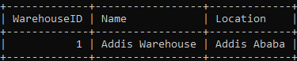
* Partition 2 (Jimma Node):
SELECT * FROM Warehouses WHERE Location = 'Jimma';
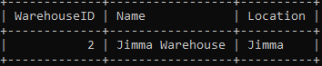
- Inventory Table (Horizontal Fragmentation by WarehouseID)
This is the most critical fragment. The inventory data must reside close to the actual physical stock. The Inventory table is horizontally fragmented using the WarehouseID mapping* Partition 1 (Addis Node):
SELECT * FROM Inventory WHERE WarehouseID = 1 -- Linked to 'Addis Warehouse';
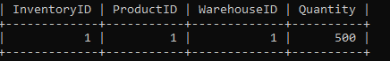
Partition 2 (Jimma Node):
SELECT * FROM Inventory WHERE WarehouseID = 2 -- Linked to 'Jimma Warehouse';
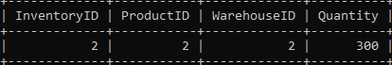
3. Shipments Table (Horizontal Fragmentation by FromWarehouseID)
Like inventory, shipment processing is tied directly to the source warehouse.
* Partition 1 (Addis Node):
SELECT * FROM Shipments WHERE FromWarehouseID = 1;
.
* Partition 2 (Jimma Node):
SELECT * FROM Shipments WHERE FromWarehouseID = 2 ; -- Shipments originating from Jimma
4. Retailers Table (Mixed Strategy)
* Horizontal Partitioning (Local View):
For operational speed, nodes will hold localized views of the retailers they primarily serve.
* Addis Node View: SELECT * FROM Retailers WHERE Location = 'Addis Ababa'
* Jimma Node View: SELECT * FROM Retailers WHERE Location = 'Jimma'
5. Orders Table (Mixed Strategy)
Orders require a mixed approach because an order might originate in one region (Addis) but need fulfillment from stock in another (Jimma).
* Local Partitioning (Primary Node):
Orders placed by a retailer in a specific region are initially stored on that region’s node (e.g., Retailer A in Jimma -> Order on Jimma Node).
* Distributed Querying (Cross-Node Fulfillment):
If the Jimma node lacks inventory, the order processor must issue a *Distributed Query* to the central repository or the Addis Node (using ShipmentID linking) to request fulfillment, moving the transaction across nodes.
6. Suppliers & Products Tables (Master Data)
These tables contain static master data. They will exist centrally but must be replicated to all nodes.
2. Replication Strategy
To balance data availability with synchronization costs, we will use a mixed replication model.
1. Asynchronous Master-Slave Replication (Master Data)
* Tables: Suppliers, Products, Warehouses (Definition only, not inventory).
* Strategy: The Central Repository is the "Master" (Single Source of Truth) for definition data. All changes (e.g., adding a new Product category) are updated on the central master node. These updates are then propagated asynchronously to all regional nodes (Addis, Jimma).
* Benefit: Provides low-latency local reads of product/supplier data on the nodes, optimizing sales and order entry. Slight delay in propagation (seconds) is acceptable for master data updates.
2. Synchronous Multi-Master Replication (High-Consistency Fields)
* Tables/Fields: Inventory (Quantity) (This requires extreme strictness).
* Strategy: In an ideal high-consistency distributed database, updates to inventory quantity (decrements during sale) should be synchronous. If Retailer A in Jimma buys 10 bags of Wheat, the system must synchronously decrement the Jimma Node Inventory.
3. Transactional Replication (Operational Data)
Tables: Orders, Shipments.
Strategy: Orders are transactions that originate locally on the Regional Node. Once the order is finalized and inventory is committed, the transaction data itself (OrderID, ProductID, Quantity) is replicated asynchronously back to the central repository for consolidated reporting.
3. Consistency, Synchronization, and Trade-offs
This system's design must navigate the trade-offs described in the CAP Theorem (Consistency, Availability, Partition Tolerance).
Data Consistency Model
We will implement a Multi-Level Consistency approach:
* Weak/Eventual Consistency: Applied to Master Data (Products, Suppliers). Local nodes serve possibly old data for a few seconds after an update centrally. This is acceptable for supply chain operational data.
* Strong/Strict Consistency: Applied strictly to Inventory Quantity. When a user looks at the inventory screen, the system must show exactly what is available across all nodes. This prevents "phantom reads" (selling stock that doesn’t exist). An order can only be confirmed if inventory on the target node can be synchronously locked.
Synchronization Between Nodes
Data synchronization will be managed using a specialized *Data Integration/Replication Service*.
* Central Repository (Data Warehouse): Collects and consolidates all replicated transactional data (Orders, Shipments, AuditLog) from regional nodes for global analytics and reporting (e.g., calculating total network inventory or global sales).
* Change Data Capture (CDC): Regional databases (Addis_DB, Jimma_DB) will utilize CDC mechanisms to monitor modifications to Orders and Shipments tables.
Trade-offs (Availability vs. Consistency)
Decision Scenario | Priority | Implemented Trade-off (CAP) Explanation
Inventory  Update (Strong) | Consistency >  Availability | The system favors Consistency (C). If the connection between the Jimma and Addis nodes fails (Partition Tolerance - P is required), the system must prioritize data correctness. In this "P" scenario, the Jimma node *must not* allow sale of stock managed by the Addis node, sacrificing immediate availability (A) of cross-region stock for guaranteed consistency (C)

8. Task 6: Failure Recovery
Database failures — whether from hardware faults, power outages, or software crashes — must not result in data loss or inconsistency. The SCM system uses a layered recovery approach combining Write-Ahead Logging, periodic checkpointing, and scheduled backups.

8.1 Write-Ahead Logging (WAL)
Write-Ahead Logging is the foundational crash recovery mechanism. All changes are written to the WAL (transaction log) before being applied to the data files. On crash recovery, the database engine:
- Reads the WAL from the last checkpoint.
- Identifies all transactions that were committed before the crash (REDO phase) and reapplies their changes.
- Identifies all transactions that were in-flight at crash time (UNDO phase) and rolls them back.
Key Guarantee
WAL ensures that a committed transaction is never lost, even if the system crashes immediately after the COMMIT acknowledgement. Uncommitted transactions are always rolled back cleanly.

8.2 Checkpointing
Periodic checkpointing flushes all dirty (modified) buffer pool pages to disk and records the checkpoint position in the WAL. This limits how far back recovery must replay the WAL after a crash. For the SCM system, checkpoints are recommended every 60 seconds during normal operation.

8.3 Backup and Restore Strategy

Backup Schedule
- Full backup: every 24 hours (off-peak hours, e.g., 02:00 local time).
- Incremental transaction log backup: every 30 minutes during business hours.
- Off-site replication: backup files transferred to a secondary storage location or cloud bucket.

Restore Procedure
- Restore the most recent full backup to the target database server.
- Apply all incremental transaction log backups in chronological order.
- Apply any remaining WAL entries from the crash point.
- Validate referential integrity: verify FK constraints, inventory non-negativity, and order status consistency.
- Open the database for connections and verify application connectivity.
8.3 Crash Recovery Scenario

Step | Action | Outcome
1 — Crash detected | Database process terminates unexpectedly | Uncommitted transaction left partial data
2 — WAL replay | Recovery process replays WAL log | Identifies committed vs uncommitted ops
3 — Rollback | Uncommitted inventory update is reversed | Inventory returns to pre-crash state
4 — Committed data confirmed | All committed orders and shipments verified | No data loss for completed transactions
5 — Service resumed | Database opens for new transactions | Full ACID compliance restored
-- Transaction in progress at crash time:
START TRANSACTION;
UPDATE Inventory SET Quantity = Quantity - 50
WHERE ProductID = 1 AND WarehouseID = 1;
-- << CRASH OCCURS HERE — COMMIT never executes >>
-- On restart, WAL recovery:
-- 1. Finds UPDATE entry in WAL — not marked as COMMITTED
-- 2. UNDO: reverses the Quantity change
-- 3. Inventory returns to pre-crash value
-- 4. System is consistent and ready for new transactions
9. Conclusion
•Schema Design: A fully normalized (3NF) relational schema with eight tables, enforced integrity constraints, and a strategic set of seven performance indexes.
•Query Optimization: Five optimized SQL queries covering inventory visibility, shipment tracking, low-stock alerting, supplier analytics, and daily reporting, all leveraging index seeks to minimize I/O under high concurrency.
•Transaction Management: Demonstrated concurrency hazards (lost updates, dirty reads) and implemented solutions using SELECT ... FOR UPDATE, SERIALIZABLE isolation, and atomic COMMIT/ROLLBACK patterns.
•Security: A four-role RBAC model with least-privilege access, strong authentication, AES encryption for sensitive data, and automated audit logging via database triggers.
•Distributed Architecture: Regional horizontal partitioning with synchronous replication for operational data and asynchronous replication for analytics, balancing strong consistency with performance.
•Failure Recovery: WAL-based crash recovery, 60-second checkpointing, and a tiered backup strategy ensuring no committed data is ever lost.
The solution demonstrates that modern relational database principles, when rigorously applied, are fully capable of supporting a distributed, high-concurrency, secure supply chain platform in a real Ethiopian business context. The design is extensible — additional regions, suppliers, and product categories can be added without schema changes.
- References
- MySQL 8.0 Reference Manual — Transactions and Locking. Available: https://dev.mysql.com/doc/
- Ramakrishnan, R. & Gehrke, J. (2003). Database Management Systems (3rd ed.). McGraw-Hill.
- Codd, E.F. (1970). A Relational Model of Data for Large Shared Data Banks. Communications of the ACM, 13(6), 377-387.
- Gray, J. & Reuter, A. (1992). Transaction Processing: Concepts and Techniques. Morgan Kaufmann.
- Kleppmann, M. (2017). Designing Data-Intensive Applications. O'Reilly Media.
- MariaDB Documentation — Replication and High Availability. Available: https://mariadb.com/kb/
- Database System Concepts (7th ed.) — Silberschatz, Korth & Sudarshan. McGraw-Hill, 2019.

